**CHINHOYI UNIVERSITY OF TECHNOLOGY**



**CUIT216 WEB DEV & E-BIZ**

**YEAR 2021**

**WEBSITE DEVELOPMENT PROJECT**

**SUBMIT BY SUBMIT TO**

RAYMOND T MAGONEKA MS CHIMHENO

C20141595F

BSIT 2:1

Table of contents:

page title

3 Introduction

4 Design considerations

4 Developers guide

7 Testing

11 Evaluation

12 Conclusion

12 References

13 Marking Grid

**Introduction**

**Business description**

Raymond Bakeries is a small private limited company that produces and sells flour-based food baked in an oven such as bread, cookies, cakes and pies. It also serves coffee and tea to customers who wish to consume the baked goods on the premises.

**Task**

We are to develop an online E-business website that sells baked goods to customers. Our duties include replenish food items according to the customers demand and needs. Ensure that bakery items are baked or cooked according to the customer`s tastes.

**Scope of the system**

Raymond Bakeries system is an E-business system that sells all types of bakeries, also allows users to check for various bakery products available at the online store. The project consists of list of bakery products displayed in various categories. Once the user makes a successful transaction he gets copy of the shopping receipts on his email id.

All the bakeries description is stored in the database for example the food name and type as well as the price etc. Users can provide feedback and recommendations through WhatsApp, Email, Phone call or Face book. On the contact us page there is a form that a user or customer can submit their queries or feedback. Below each bakery there is a “**learn more”** button where one is provided with a full description of each gadget.

**System Objectives**

The system aims to minimize queues at Raymond Bakeries, also provides an in site of company, what it does and the services offered. The system should be able to go to each page that the user navigates to. It should be able to fetch data from the database and display it as required. It should be user friendly. The system will allow Raymond Bakeries to maintain their entire record in one place which will be easy to manage. It will also reduce the risk of errors.

12

**System development documentation**

**Design Considerations**

Colors: the colors I used helps customers to clearly see the available products and all the necessary information they would want to know about Raymond Bakeries.

Font style and size: I used Times New Roman size 12 because it`s readable.

Navigation: It has a sticky header that allows users to quickly access the navigation. It also increase discoverability of the elements in the header and the chance that users will take advantage of them.

**Developers Guide**

**Physical design and programming environment**

This gives a description of how the proposed solution will be developed into a working and functional prototype. Information on the programming principles observed during the developing stage and the language used will also be included. Also, the IDE used

**Tools used**

1. Visual Studio Code
2. Access database
3. Chrome Browser
4. Paint

**Visual Studio Code**

It contains completion tools, and other features of facilitate the web development process. I used it to design the whole web (home page, about us etc).

**Access database**

Since it is an information management tool that helps to store information for reference, I used it to store all my database for example on my bakeries page you can see all the baked available.

**Chrome**

I used it for accessing my web pages.

**Paint**

…………

**Where some of the code was used**

**Testing**

The testing phase examines the performance of each existing function as well as additional functionality. In the testing phase, different methods are used to test the behaviour of each task.

**(Home page 1)**

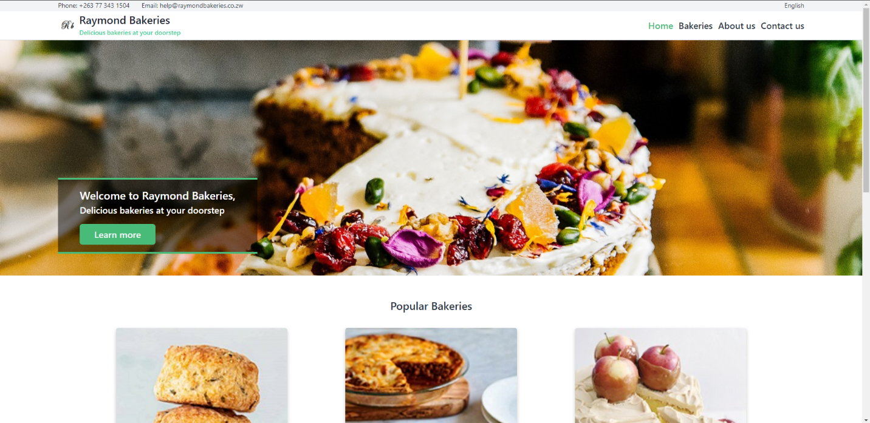

**(Home page 2)**

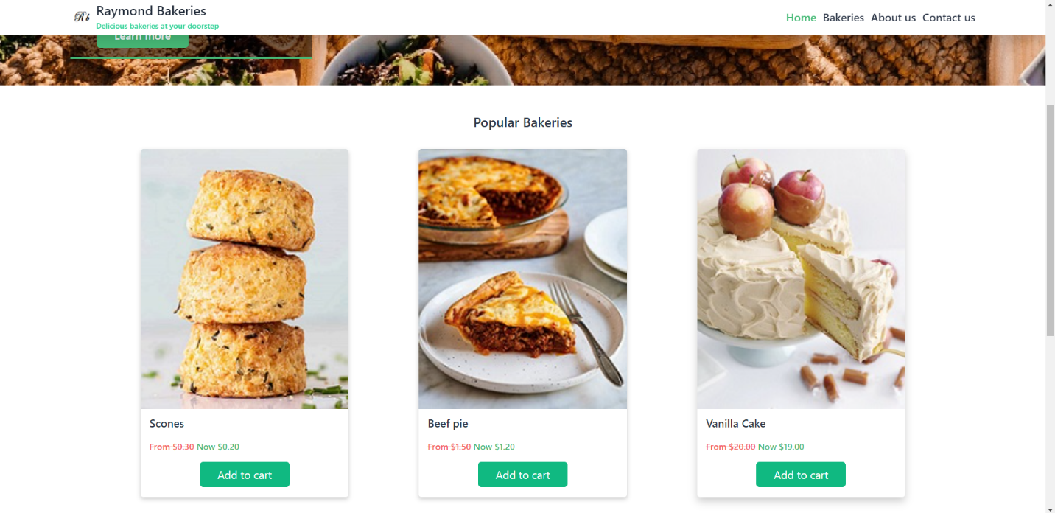

**(Home page 3)**

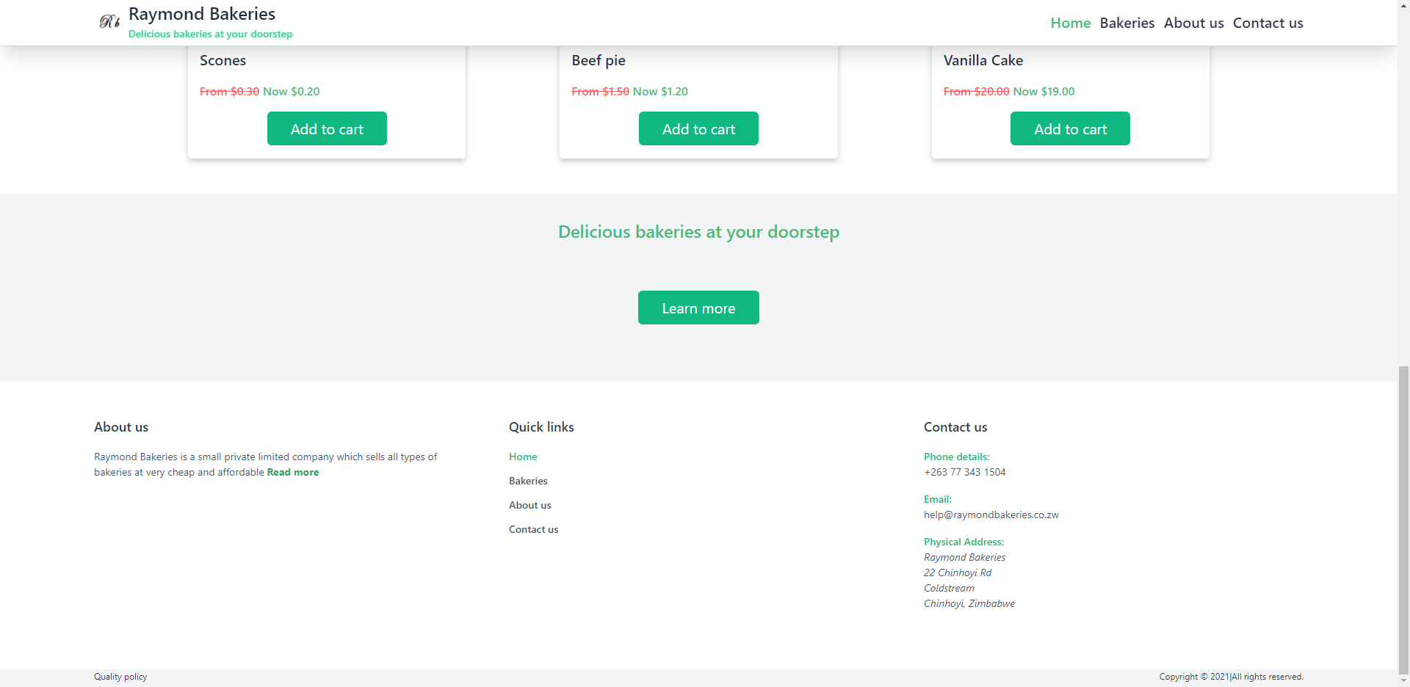

**(Product page 1)**

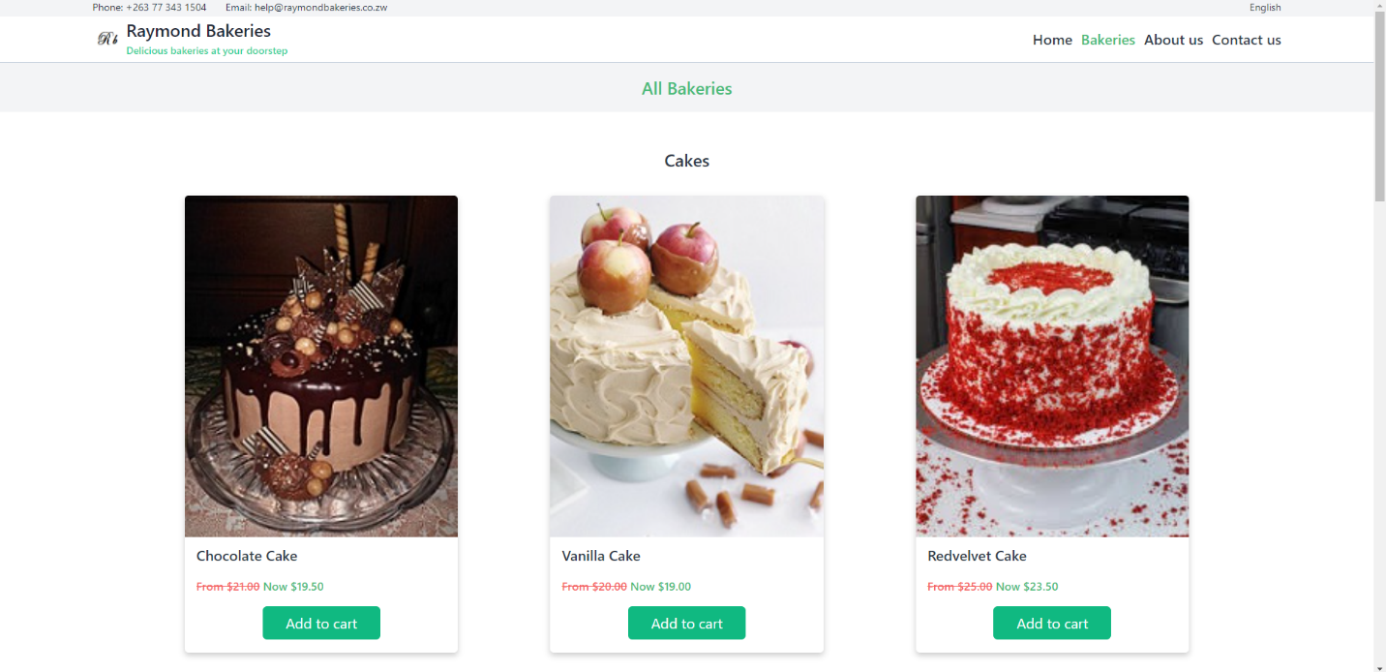

**(Product page 2)**

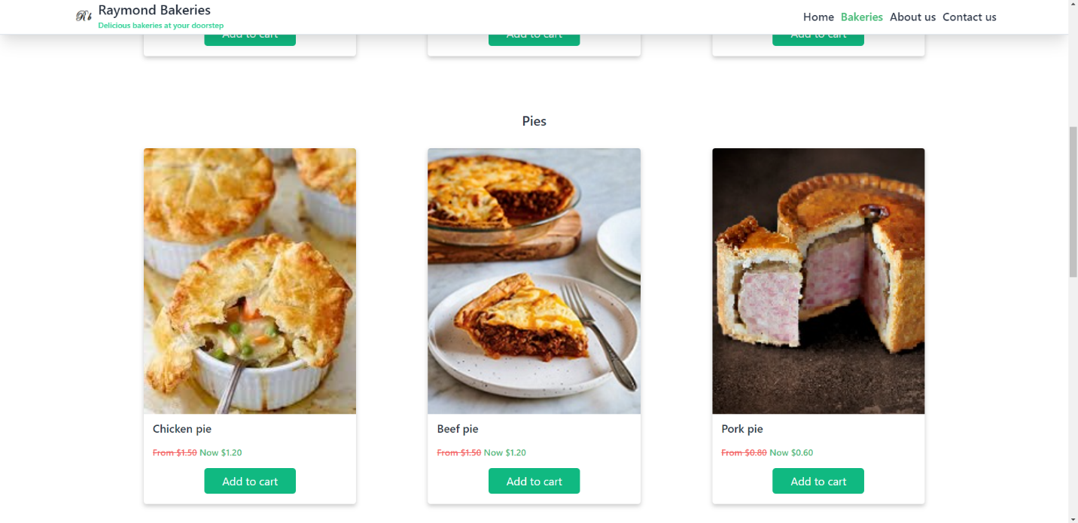

**(Product page 3)**

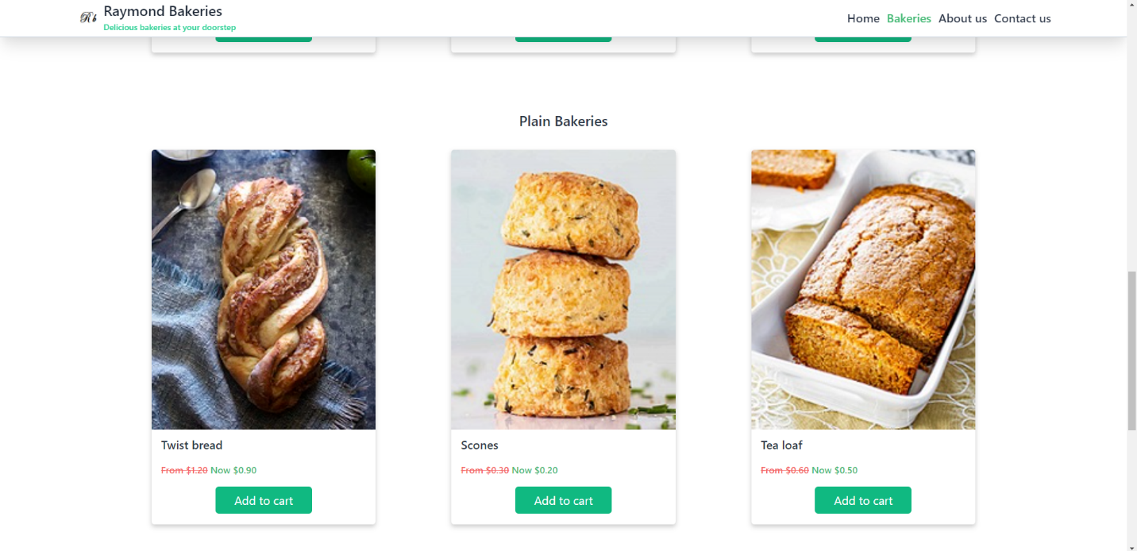

**(Product page 4)**

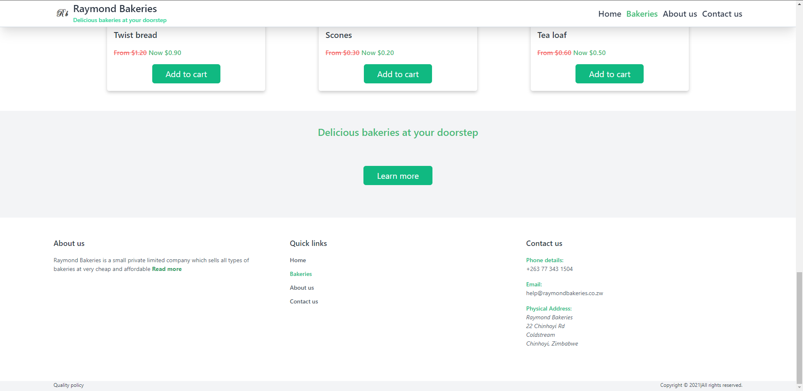

**(About Us 1)**

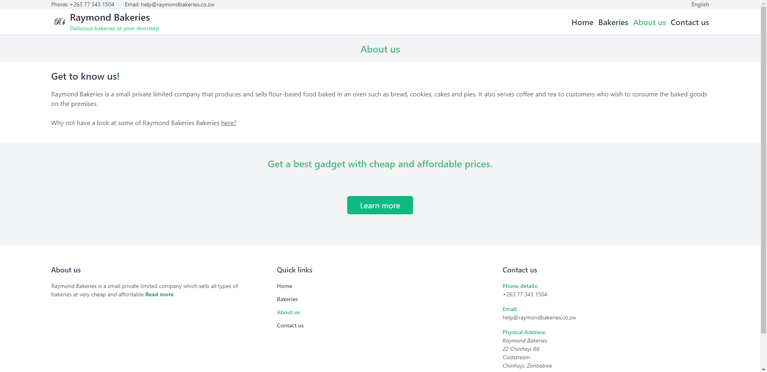

**(Contact Us 1)**

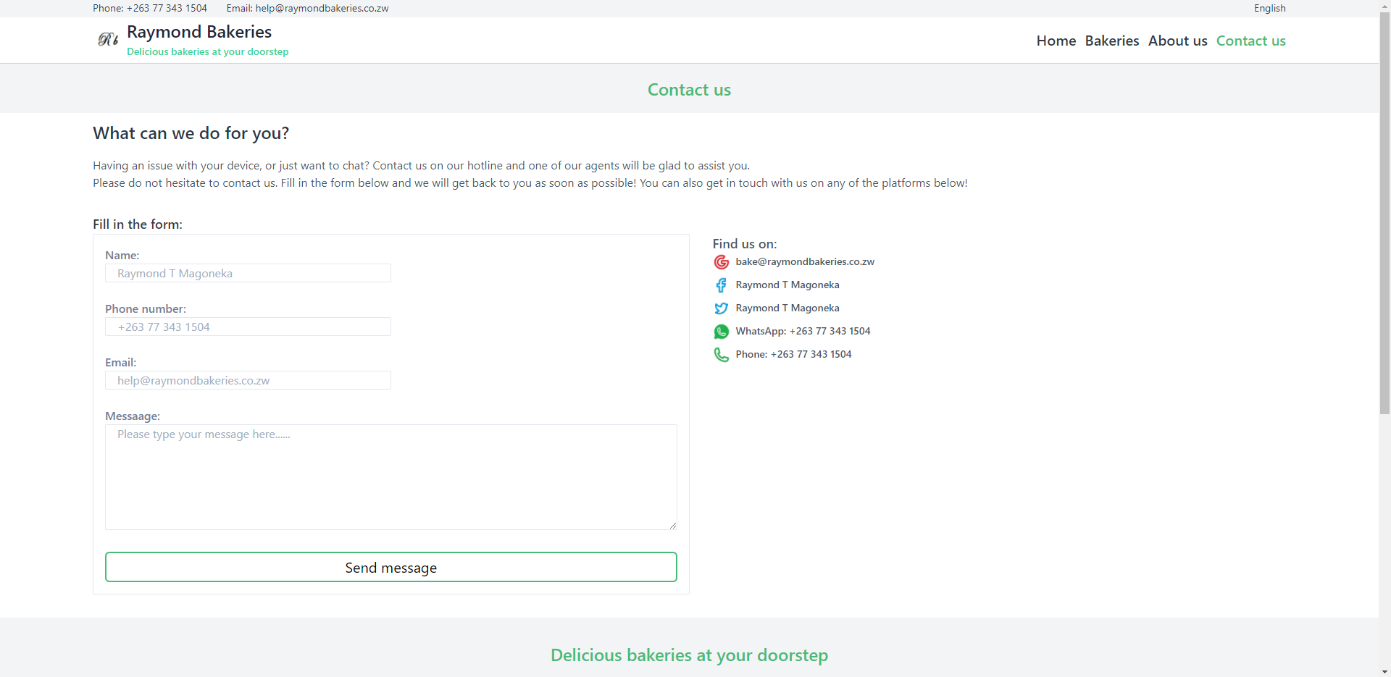

**(Contact Us 2)**

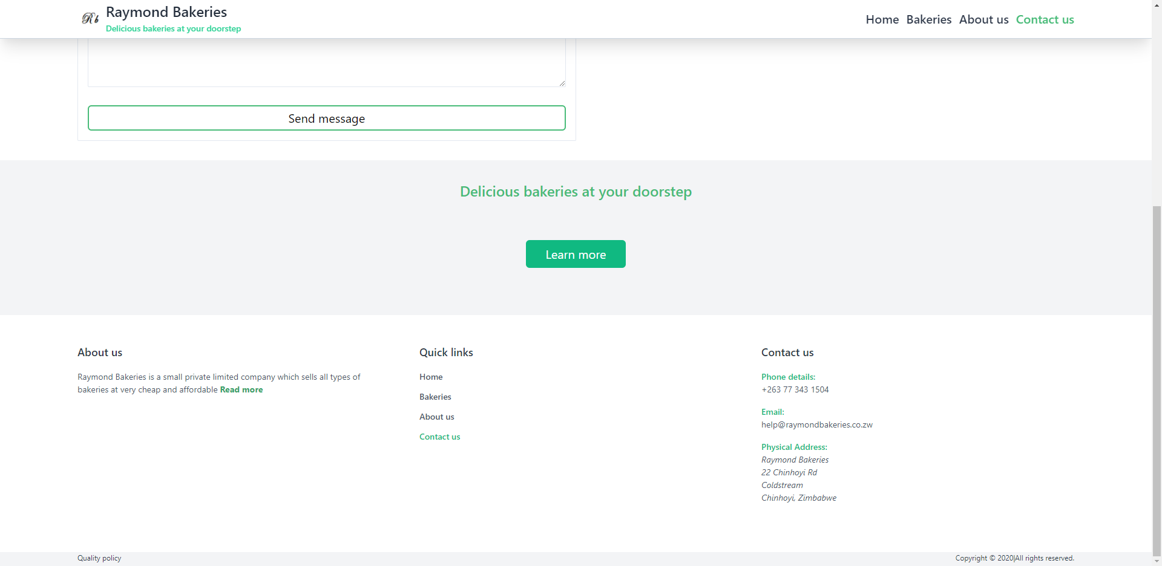

**Instructions on how to install the software**

* As long as one has any web browser on their PC they can open the software.

**Reference guides**

These are the technical references of our software’s code and basic description of the software.

**Evaluation**

**Recommendation:**

1. The changed user behaviour due to permanent information and price transparency, and the demand individualism, regionalism, organic products and sustainability.
2. Growing legal requirements and high retail standards.
3. Assurance of the product quality
4. Cost pressure due to pricing requirement in the industry`s market leaders and increasing raw materials costs.

**Conclusion**

Although some of the links have failed to work, the one`s that do, work as they are supposed to. Using PHP was a bit of challenge but manageable. The application is user friendly. Anyone will be able to use it without much of problem. The design is okay for the eyes and there is easy navigation. Working on this project was a bit challenging but I managed to learn how to use html and java script programming language. I did not manage to link the application in time for submission but I will continue to learn and link it to so I know how it is done.

**References**

|  |  |
| --- | --- |
| |  | | --- | | https://mail.google.com/mail/u/0/images/cleardot.gif | |

<https://youtu.be/dtTWD0ystG0>

<https://youtu.be/uyaV_EWWRmo>

<https://youtu.be/-4i8zbBcC7E>

<https://youtu.be/PgAZ8KzfhO8>

**Marking** **Grid**

|  |  |  |
| --- | --- | --- |
|  | **Marks Allocated** | **Marks Given** |
| Application and Navigational function | 15 |  |
| Web Forms | 12 |  |
| Connected Database | 8 |  |
| Developer’s Guide | 10 |  |
| Testing | 10 |  |
| Design Considerations | 5 |  |